**Project Design Phase-II**

**Data Flow Diagram & User Stories**

|  |  |
| --- | --- |
| Date | 03 October 2022 |
| Team ID | PNT2022TMID33418 |
| Project Name | Project – A Novel Handwritten method for digit recognition |
| Maximum Marks | 4 Marks |

**Data Flow Diagrams:**

**This Data Flow Diagram tell about the A Novel Handwritten method for digit recognition using deep learning**

**In this data entered by image given by the user and the image could be processed and it should be evaluated and**

**Given to the user , this should be done in this model , it should shown in the diagram**

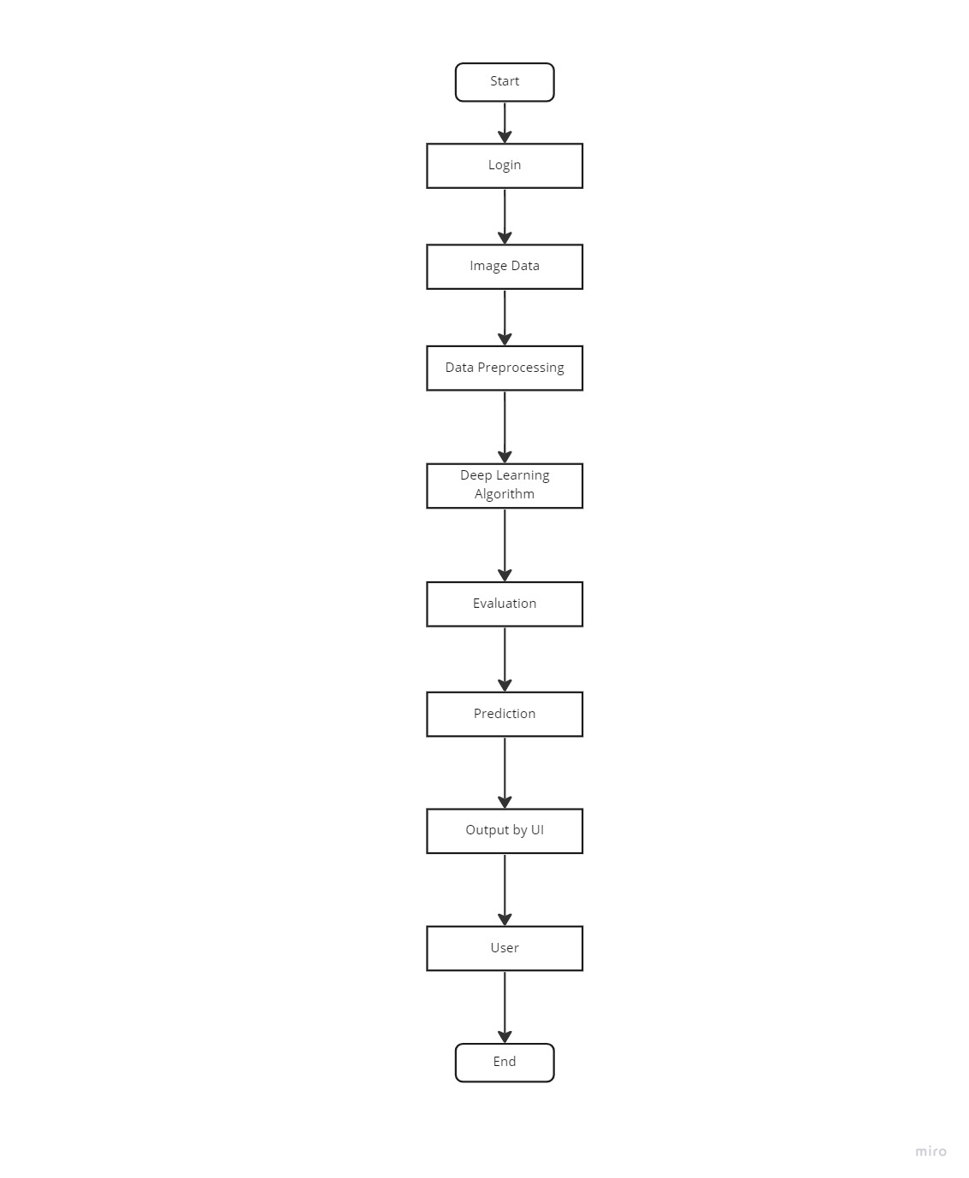

**User Stories**

Use the below template to list all the user stories for the product.

| **User Type** | **Functional Requirement (Epic)** | **User Story Number** | **User Story / Task** | **Acceptance criteria** | **Priority** | **Release** |
| --- | --- | --- | --- | --- | --- | --- |
| Customer (Mobile user) | Registration | USN-1 | As a user, I can register for the application by entering my email, password, and confirming my password. | I can access my account / dashboard | High | Sprint-1 |
|  |  | USN-2 | As a user, I will receive confirmation email once I have registered for the application | I can receive confirmation email & click confirm | High | Sprint-1 |
|  |  | USN-3 | As a user, I can register for the application through Facebook | I can register & access the dashboard with Facebook Login | Low | Sprint-2 |
|  |  | USN-4 | As a user, I can register for the application through Gmail |  | Medium | Sprint-1 |
|  | Login | USN-5 | As a user, I can log into the application by entering email & password |  | High | Sprint-1 |
|  | Dashboard | USN-6 | As a user, I can able to understand the user Interface it should not be a complex interface |  | High | Sprint-1 |
| Customer (Web user) | Login | USN-6 | I can able to login in by a web user by login id and password |  |  |  |